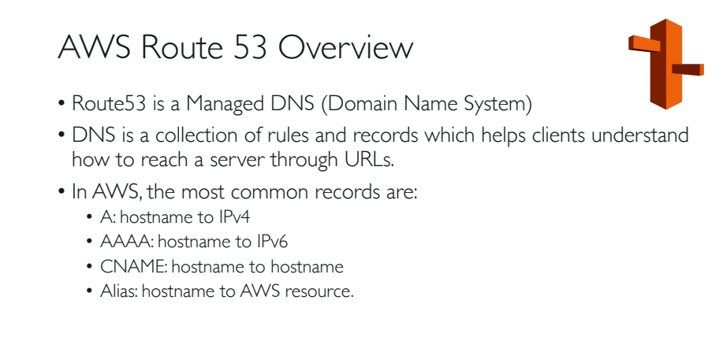

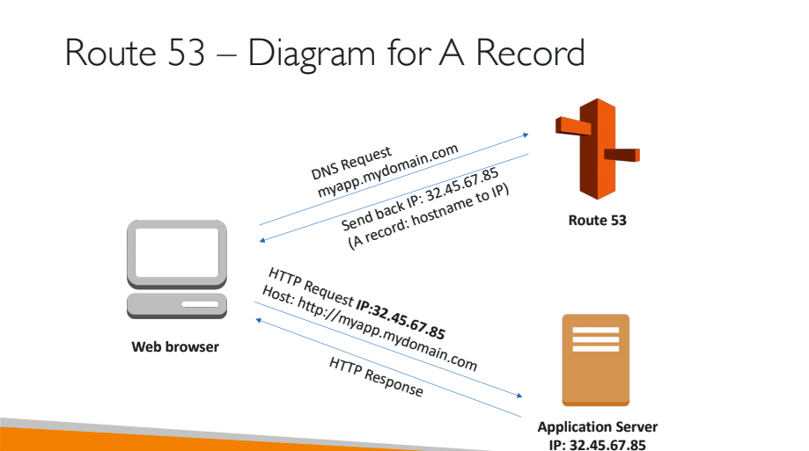

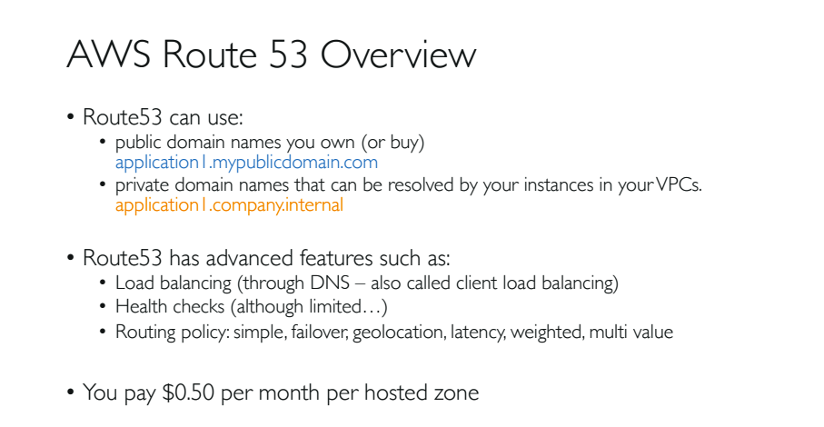

1. AWS Route 53(DNS) maintains records in the form of database.
2. This link gives basic overview of Route 53: <https://docs.aws.amazon.com/Route53/latest/DeveloperGuide/Welcome.html>
3. Different types of Route 53 records descriptions: <https://docs.aws.amazon.com/Route53/latest/DeveloperGuide/ResourceRecordTypes.html>
4. Different types of Routing policies explained in the following link: <https://docs.aws.amazon.com/Route53/latest/DeveloperGuide/routing-policy.html>

yum install update -y

yum install httpd -y

service httpd start

systemctl enable httpd

echo "<h2>Welcome to AWS Route 53 service</h2>" > /var/www/html/index.html

(or)

#!/bin/bash

yum update -y

yum install -y httpd

systemctl start httpd.service

systemctl enable httpd.service

EC2_AVAIL_ZONE = $(curl -s http://169.254.169.254/latest/meta-data/placement/availability-zone)

echo "<h1>Hello World from $(hostname -f) in AZ $EC2_AVAIL_ZONE </h1>" > /var/www/html/index.html

1. Create 3 different instances in 3 different regions using the above ‘user data’ script.
2. Note down the instance ipv4 addresses of all 3 instances

Example:

172.31.13.80 – Virginia

65.0.7.42 – Mumbai

18.140.249.190 - Singapore